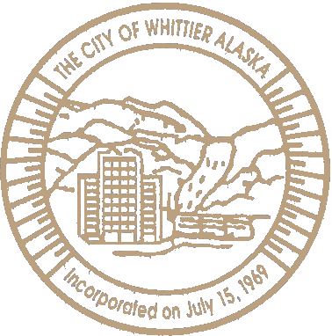

June 30, 2021

THE CITY OF WHITTIER

*Gateway to Western Prince William Sound*

P.O. Box 608 • Whittier, Alaska 99693 • (907) 472-2327 • Fax (907) 472-2404

Bureau of Land Management

Attn: East Alaska RMP Amendment/EA 222 W. 7th Ave., Stop 13

Anchorage, AK 99513

Re: East Alaska RMP Amendment and Environmental Assessment

I am writing on behalf of the City of Whittier, Alaska to express support for Alternative 2 of the East Alaska RMP Amendment/EA to support a potential land exchange with Chugach Alaska Corporation (Chugach) to help meet the requirements of Section 1113 of the Dingell Act that calls for the Chugach Region Land Study and land exchange.

The Chugach Region Land Study and exchange came about because of the Exxon Valdez Oil Spill (EVOS) habitat acquisition and protection program. Under this program, EVOS settlement funds were used to purchase surface estate lands from village corporations who were significantly harmed by the spill. These native lands were deeded to the federal government with restrictive conservation easements placed on the property. On lands where Chugach owned the subsurface estate, this created a conflict related to land management issues and has created significant harm to Chugach in terms of their ability to utilize their lands as intended under the Alaska Native Claims Settlement Act (ANCSA).

This exchange has cultural significance for the Alaska Natives in the Chugach region. In prehistoric and historic times, the Chugach people used trade routes up the Copper River, Lowe River and across the Whitter portage into Cook Inlet where they traded with their Athabaskan neighbors. Therefore Chugach, along with Tatitlek, selected the adjacent property as part of their original land claims under the ANCSA. Access to cultural lands is of highest priority for the Alaska Natives of the Chugach regioin addition to the Chugach people being the original and rightful stewards of the land, the following information provides additional reasons that support the exchange:

As part of the land exchange, Chugach has agreed to a 17(b) trail easement which would provide public access from the Richardson Highway to the Lowe River. This easement will allow for hikers and recreational vehicles such as snowmachines and four-wheelers.

* There are more than 10,000 acres in the same area that are more accessible for recreational use and this exchange. The recreational lands outside of the exchange are easily accessed from the Richardson Highway and support a wide array of year-round recreational uses.

[www.ci.whittier.ak.us](http://www.ci.whittier.ak.us/)

* This exchange would consolidate Chugach' s land holdings, and it would consolidate land holdings for the Federal government as Chugach would provide, in exchange, 1,256 acres currently held within the external boundaries of the Wrangell-St. Elias National Park, a designated Wilderness Area. Wilderness areas are highly valuable for their historical, scientific, educational, geologic and ecological benefits.

In short, Chugach's proposed land exchange in the Thompson Pass area would not disrupt public access to recreational areas as the vast majority of the recreational access is not in the area identified for the exchange. The detailed maps of the area (attached) demonstrate the minimal impact an exchange would have.

Furthermore, the exchange would connect Chugach and Tatitlek lands to Alaska's road system while consolidating land holdings for Chugach and the federal government.

Thank you for this opportunity to comment.

y

Jim Hunt

City Manager, Whittier, Alaska [citymanager@whittieralaska.gov](mailto:citymanager@whittieralaska.gov) 907-202-2442

TOPOI map pnni.d on 04/22/08 from 'Wq,"""'° Skling,tpo"

**l**◄**So .ooo • W 1"'5•**:o**2**r**.**l**0**w**0**!,**0**..**'**..**W**,,,......_**145•4**,**0**.**.**.**0**_=**00**-**' W**- **145**-**•38**-**.0**-**00' w**

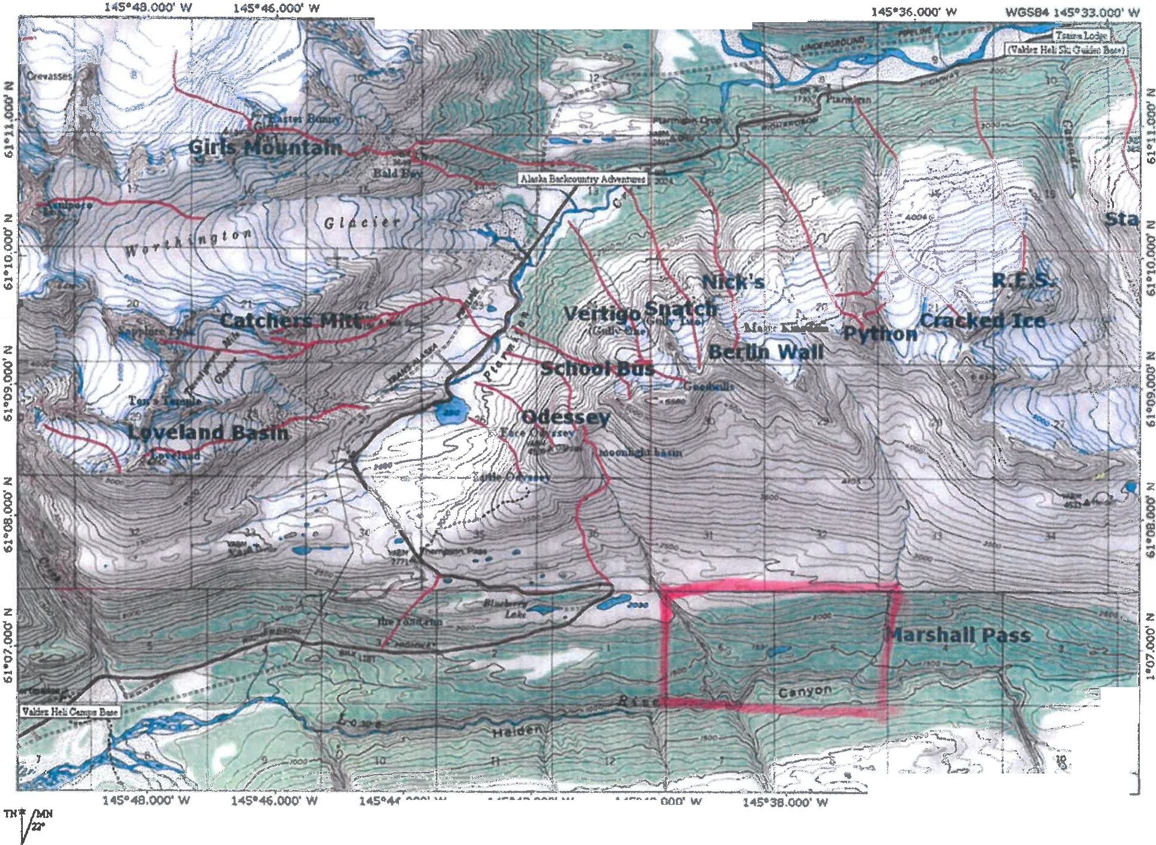

"'

. **00 OJ ' UI** IJ . **2.0lillllN**

· *s.*

¼' ••

.....- ....-01001........,_,..1...........,,,..,..._,

(. --

.,

,_,

-- -,/'!: --

";_,"·-

"'- }::'-

*--...;?!* ' - · \\

**145•36.000' W WGSB4 14S•33,000' W**

*Map depicting ski trails in Thompson Pass area* - *highlight shows land exchange area*

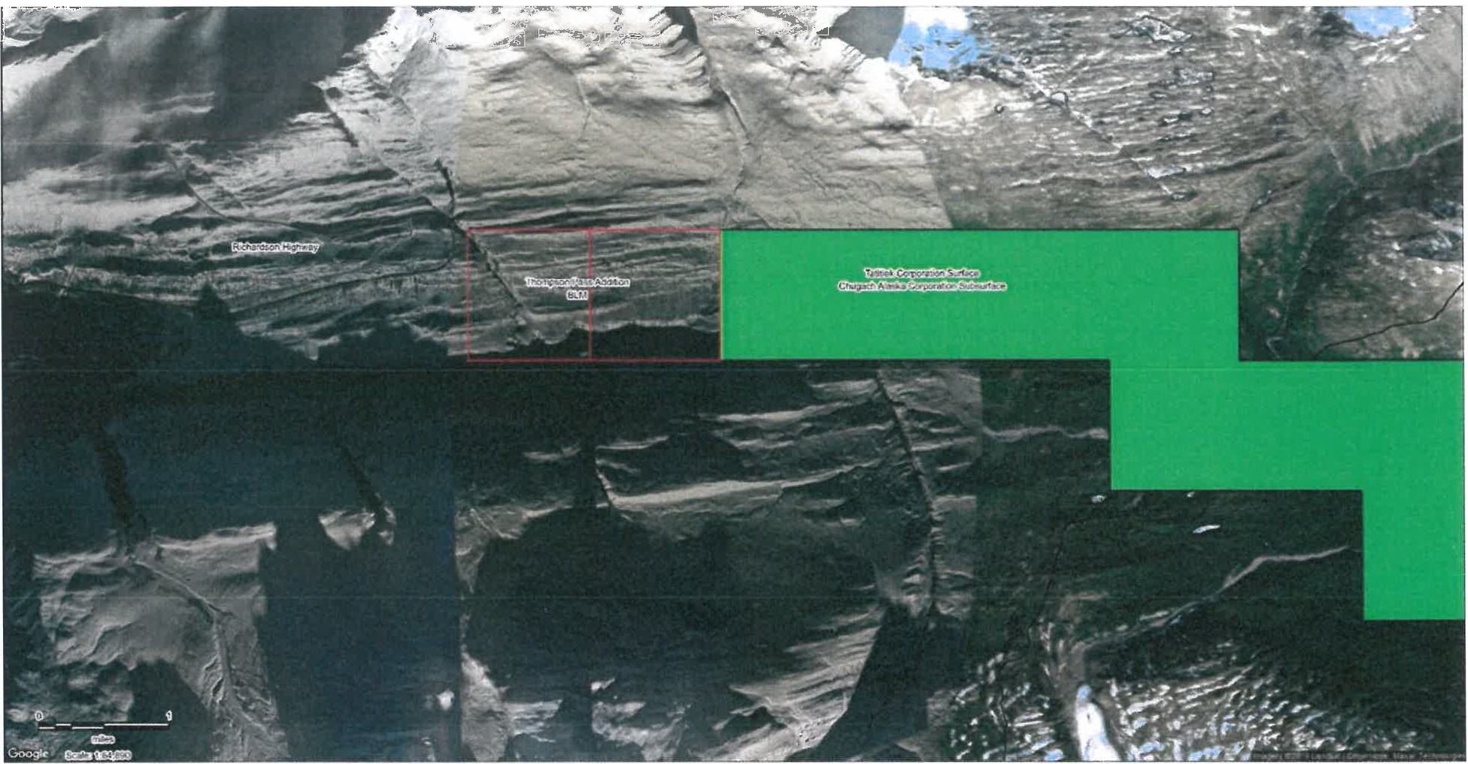

*Satellite map showing land exchange area in relation to lands owned by Chugach and Tatitlek*